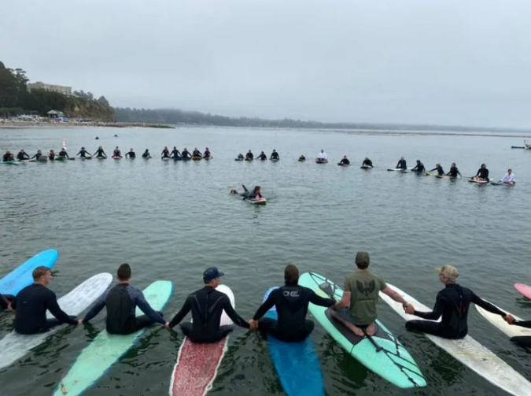

VETERAN SURF ALLIANCE
Mission

Veteran Surf Alliance is a Santa Cruz based nonprofit that creates fellowship and community among veterans through surfing, easing the transition between military service and civilian living.

HOW?

We accomplish this by teaching, coaching and mentoring veterans to surf and be respected members of their communities, providing access to surfboards, vital equipment, routine surf meetups and annual events.

Our Vision

To smooth the transition between military service and civilian living through surfing. We want veterans to find the same type of camaraderie they had while serving in the military with members of their community.

We meet in Santa Cruz the last Saturday of every month and in Pacifica every Tuesday, rain or shine. The Central Coast Chapter in Pismo Beach meets regularly. Our members travel from San Francisco, Santa Cruz, and as far as Sacramento and Fresno. We meet all over the Northern California coast.

We are a peer-led supportive community that fosters friendships, camaraderie, and stoke. We provide soft top surfboards, wetsuits, and instruction to newcomers. We typically surf for about 2 hours, where we all share in the experience that the ocean offers that day, then share in a post-surf snack. Being a member of the VSA encourages a better sense of self and community. The VSA is excited to be expanding and welcoming new members and supporters, stickers included! There are no membership dues or fees.

"Camaraderie and therapy with a veteran focused community. And I am able to interact with veterans who I serve with. I am able to heal my issues in the ocean. The ocean gives me the opportunity to express myself in a manner that I have never found possible on dryland. Access to the oceans provided by the VSA has helped me learn how to readjust and surf through the challenges of life and overcome injuries. "
Nick R.
Army Soldier, Purple Heart Recipient

Code of Conduct

1) Spread the Stoke with your fellow veterans and VSA surfers - Have fun !
2) Surf with the VSA as often as personal and Ocean conditions allow.
3) Surf to your ability - go after the bigger waves when ready.
4) Encourage the newest VSA surfer to catch the wave. There will always be another wave.
5) Listen to your fellow VSA surfer when they want to talk. Lift each other up when down.
6) Honor the VSA - avoid inflammatory/threatening/violent behaviors in and out of the Ocean.
7) Respect the VSA - do not get intoxicated at VSA community events and please respect personal space.

